

ELECTROTEK ANAEROBIC WORKSTATION

AW4500 SINGLE / DUAL GAS TOUCHSCREEN CONTROLLER

CONTENTS

1. | OVERVIEW | 1
2. | GENERAL FEATURES
 | a) Startup Page | 2
 | b) Main Page | 2
 | c) Temperature Controller Page | 4
 | d) Humidity Controller Page | 5
 | e) O2 Display Page (if fitted) | 6
 | f) Main Settings Page | 7
 | g) Advanced Settings Page | 8
 | h) Alarms List Page | 10
1. OVERVIEW

This document refers to the touchscreen control panel used in Electrotek’s AW400 and AW500 anaerobic workstations, both single and dual gas types. It should be used in conjunction with the operator’s manual.

2. GENERAL FEATURES

a) Startup

On applying power to the system, an intro screen will be displayed for five seconds. This contains two pieces of information – the serial number and model number of the cabinet.

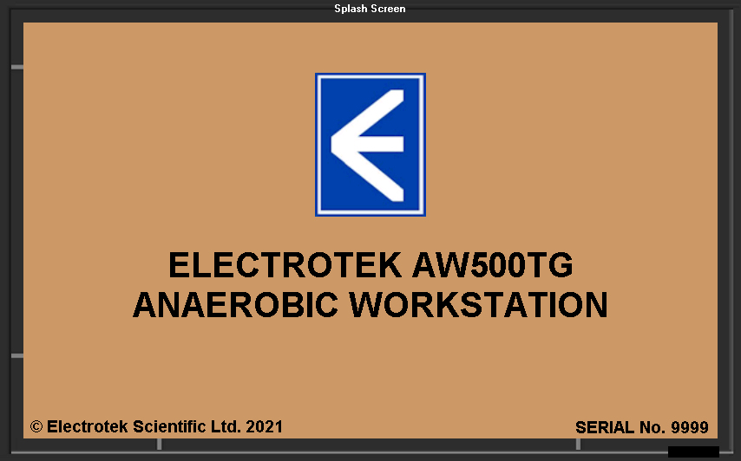

After five seconds, the main control page will be displayed and the pulsed alarm will sound to warn the user that the mains supply has been interrupted.

As with most audible alarms on the cabinet, this alarm can be silenced and in this case cancelled by the silence alarm button. In most cases, the silence alarm button will only cancel the audible alarm and will not cancel the display of the alarm condition. If the cabinet loses its mains supply, the battery operated continuous alarm will sound until the mains is restored.

b) Main Page

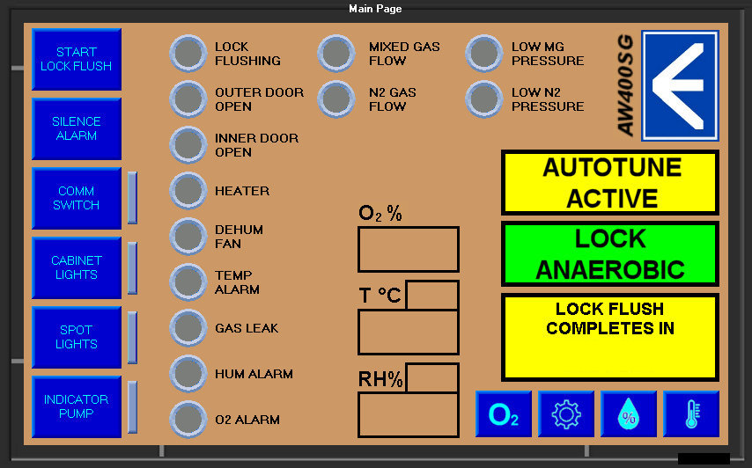

Left buttons

Start Lock Flush – Initiates lock flushing, provided that both doors are closed and there is sufficient gas pressure.

Silence Alarm - Silences the audible pulsed alarm. In the case of a gas leak or mains failure warning, the button also clears the fault. In all other cases, the fault warning remains until the fault is cleared.

Comm Switch - The commissioning switch allows the lock flush to continue past the five minute limit for commissioning purposes. While activated, the yellow warning bar will announce this.

Cabinet Lights - Switches the main cabinet lights on and off.

Spot Lights - Switches the spot light(s) on and off.

Indicator Pump - Switches the socket controlling the indicator pump on and off.

Indicator Lamps

Lock Flushing - Lit whenever the cabinet is flushing the lock.

Outer Door Open - Lit whenever outer door is open.

Inner Door Open - Lit whenever inner door is open.

Heater - Lit whenever the heater element is powered. This will flash when the cabinet is on or close to its set temperature.

Dehum Fan - Lit whenever the dehumidifier fan is active.

Temp Alarm - Lit whenever the temperature of the cabinet is outside the constraints set by the temperature high and low alarms (when enabled).

Gas Leak - Lit whenever the system has detected a gas leak, i.e. the mixed gas solenoid has been active for a continuous period of more than two minutes.

Hum Alarm - Lit whenever the humidity of the cabinet is outside the constraints set by the humidity high and low alarms (when enabled).

O₂ Alarm - Lit whenever the oxygen level of the cabinet is outside the constraints set by the oxygen level high and low alarms (when enabled). (Only visible if sensor unit fitted)

Mixed Gas Flow - Lit whenever the mixed gas solenoid is active.

N₂ Gas Flow - Lit whenever the N₂ gas solenoid is active.

Low MG Pressure - Lit whenever the mixed gas pressure is below that set on the mixed gas pressure switch.

Low N₂ Pressure - Lit whenever the N₂ gas pressure is below that set on the N₂ gas pressure switch.

Centre Displays

O2 % Displays the current O₂ concentration. (Only visible if sensor unit fitted)

T °C The larger digits display the current cabinet temperature. The smaller digits display the set temperature.

RH% The larger digits display the current cabinet humidity. The smaller digits display the set humidity.

Info Bars

Top Info Bar - Displays alarms and information such as commissioning mode or heater system autotune. Only visible under alarm or necessary information conditions.

Centre Info Bar - Displays the current aerobic / anaerobic condition of the cabinet.

Lower Info Bar - Displays the time remaining on a lock flush. Only visible during lock flushes.

Lower Right Buttons

O₂ PB - Press to access the O₂ settings page. (Only visible if sensor unit fitted)

Settings PB - Press to access the settings / advanced settings pages. If a password has been set, this will be required for access.

Humidity PB - Press to access the humidity controller page.

Temperature PB - Press to access the temperature controller page.

c) Temperature Page

Graph - Shows the temperature setting and actual temperature data collected since the last power cycle of the cabinet. Pressing the ‘M’ button on the left allows viewing of the recorded data, while pressing the ‘M’ button again returns the display to current data. While in memory mode, a pair of arrow buttons at the bottom of the graph allow the user to move through the data in terms of time. Date and time are displayed on the left and right of the X-axis.
Pressing the ‘G’ button applies a horizontal grid to the display.

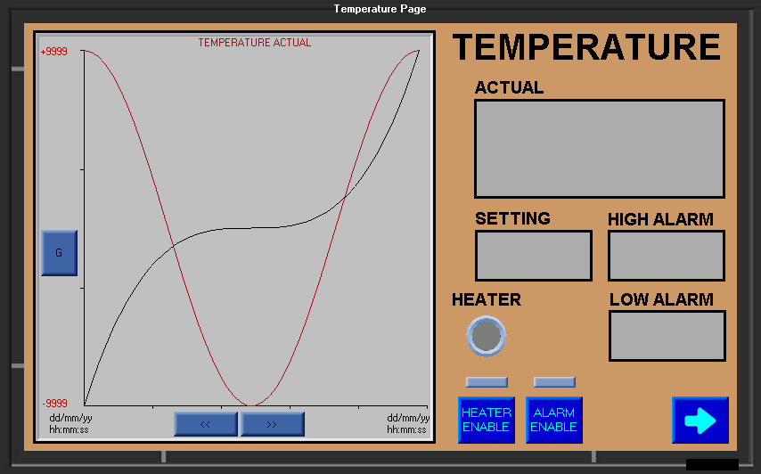

Actual - Displays the current cabinet temperature.

Setting - Displays the desired set point of the temperature. To adjust this, press the grey setting display and a numerical keypad will appear, as below.

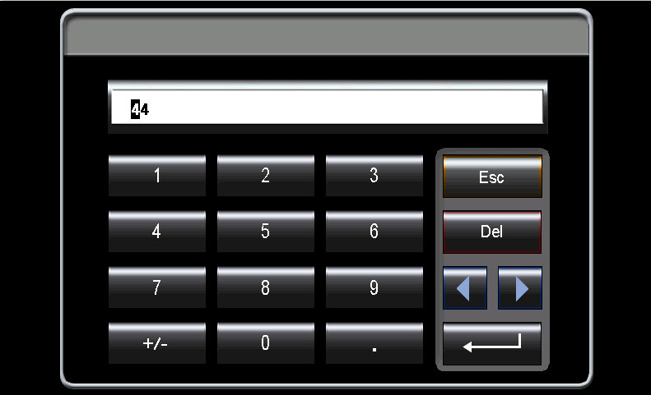

High / Low Alarm - These display the high and low limits of temperature for the temperature alarm. They can again be adjusted by pressing the grey displays and entering a new value on the numerical keypad.

Heater Indicator - Lit whenever the heater element is powered. This will flash when the cabinet is on or close to its set temperature.

Heater Enable - Switches the heating system on and off.

Alarm Enable - Switches the temperature alarm system on and off. It is recommended that this is switched off when setting up the cabinet.

Back Button - (Right arrow) This button navigates back to the main page.

d) Humidity Page

Graph - Shows the humidity setting and actual humidity data collected since the last power cycle of the cabinet. Pressing the ‘M’ button on the left allows viewing of the recorded data, while pressing the ‘M’ button again returns the display to current data. While in memory mode, a pair of arrow buttons at the bottom of the graph allow the user to move through the data in terms of time. Date and time are displayed on the left and right of the X-axis.
Pressing the ‘G’ button applies a horizontal grid to the display.

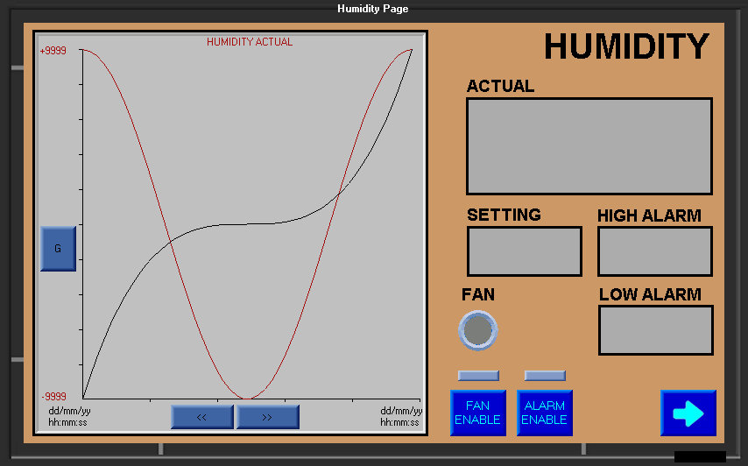

Actual - Displays the current cabinet humidity.

Setting - Displays the desired set point of the humidity. To adjust this, press the grey setting display and a numerical keypad will appear, as below.

High / Low Alarm - These display the high and low limits of humidity for the humidity alarm. They can again be adjusted by pressing the grey displays and entering a new value on the numerical keypad.

Fan Indicator - Lit whenever the dehumidifier fan is powered.

Fan Enable - Switches the dehumidifier system on and off.

Alarm Enable - Switches the humidity alarm system on and off. It is recommended that this is switched off when setting up the cabinet.

Back Button - (Right arrow) This button navigates back to the main page.

e) O₂ Page

(This page is only available if the O₂ sensor unit is fitted)

Graph - Shows the actual O₂ data collected since the last power cycle of the cabinet. Pressing the ‘M’ button on the left allows viewing of the recorded data, while pressing the ‘M’ button again returns the display to current data. While in memory mode, a pair of arrow buttons at the bottom of the graph allow the user to move through the data in terms of time. Date and time are displayed on the left and right of the X- axis. Pressing the ‘G’ button applies a horizontal grid to the display.

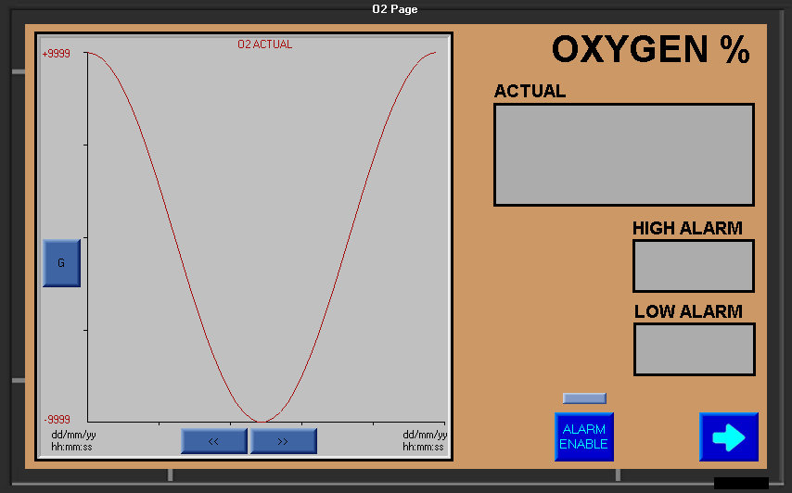

Actual - Displays the current cabinet humidity.

High / Low Alarm - These display the high and low limits of humidity for the humidity alarm. To adjust this, press the grey setting display and a numerical keypad will appear, as below.

Alarm Enable - Switches the O₂ alarm system on and off. It is recommended that this is switched off when setting up the cabinet.

Back Button - (Right arrow) This button navigates back to the main page.

f) Main Settings Page

Network Address - This is the network address of the cabinet. Press each segment of the address to set / edit the address.

Subnet Mask - This is the subnet mask of the cabinet. Again, these are set by individual segment.

Default Gateway - The default gateway of the connection or network. Again, these are set by individual segment.

All changes to these settings must be confirmed by pressing the ‘Apply’ button when complete.

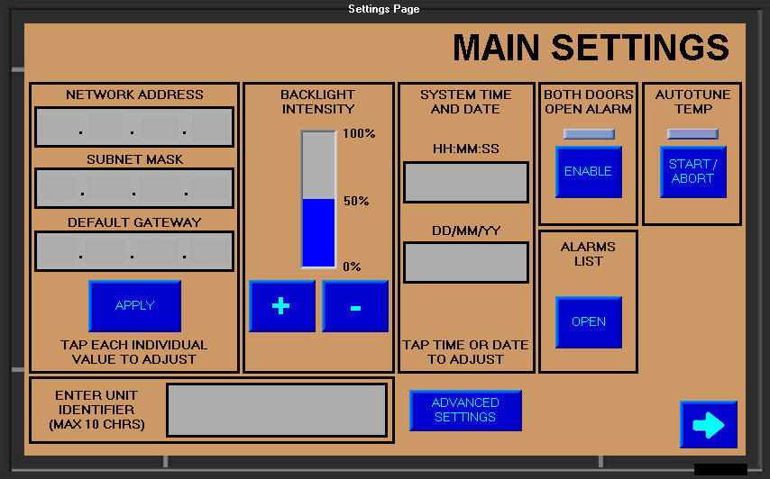

Unit Identifier - This is the cabinet name. It is used to identify the cabinet to the data logging or remote control software. To enter / edit, press the grey area and enter the name on the alphanumeric keypad which will appear as below. This is only saved on a power cycle, so the unit must be restarted.

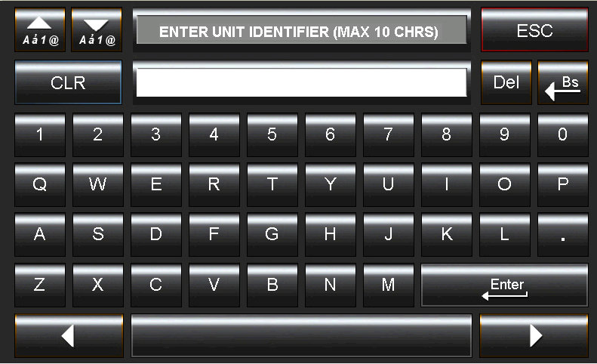

System Time / Date - This can be set manually or by the datalogging software. To set manually, press the grey areas and input the details via the numeric keypad which will appear.

Both Doors - This enables the optional alarm which sounds if both doors are Open Alarm opened at the same time.

Autotune Temp - This starts the temperature controller autotune. This is an automatic procedure which trims the temperature controller software for its particular environment. The procedure can take around an hour to complete and will cause temperature overshoot, so it is not advisable to perform this with experimental material in the cabinet. This procedure has already been done during manufacturing and should not need to be repeated on site.

Alarms List - This opens the alarms list page.

Advanced Settings - This opens the advanced settings page.

Back Button - (Right arrow) This button navigates back to the main page.

g) Advanced Settings Page

O2 Offset - This allows an offset of +/-5% to be entered to correct for O₂ sensor variation and sensor positioning inside the cabinet during calibration. To enter an offset, press the grey area and enter the offset using the numerical keypad which appears. (Only available if sensor unit fitted)

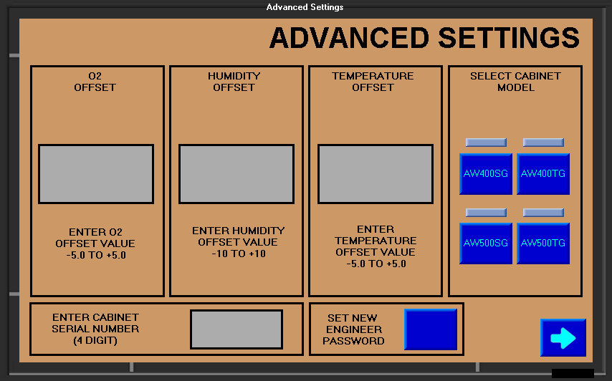

Humidity Offset - This allows an offset of +/-10% to be entered to correct for humidity sensor variation and sensor positioning inside the cabinet during calibration. To enter an offset, press the grey area and enter the offset using the numerical keypad which appears.

Temperature Offset - This allows an offset of +/-5°C to be entered to correct for temperature sensor variation and sensor positioning inside the cabinet during calibration. To enter an offset, press the grey area and enter the offset using the numerical keypad which appears.

Cabinet Serial no. - This is the cabinet serial number which appears on the intro screen. It is useful when ordering spares and reporting any issues to engineers. This should not be changed by the user.

Set New Engineer - This button allows the user to enter change the password which Password protects the main and advanced settings pages. If no password is set or it is set to blank and saved, a user will be able to access theses settings pages by pressing the settings button on the man page. Once a password has been entered and saved, this will prevent unauthorised access. When pressed, this button will bring up a password entry dialog box as below.

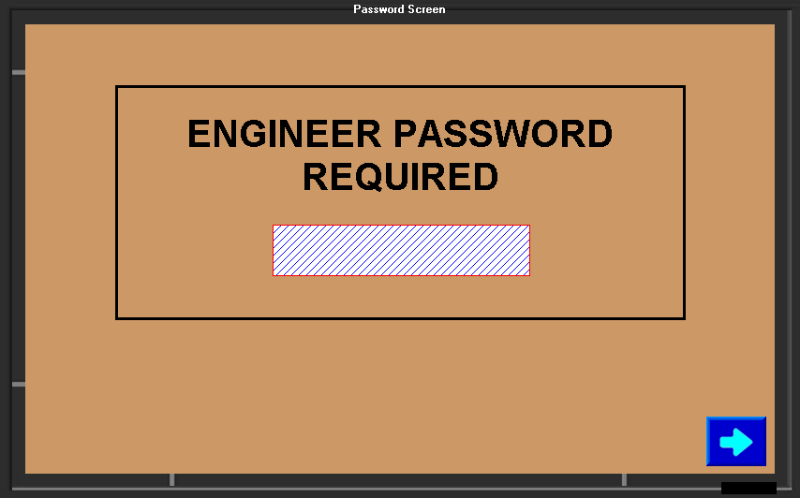

Pressing the grey area will access the alphanumeric keypad. Once the password is set, press the back button to return to the previous page.

Select Cabinet - Pressing one of these buttons selects the model of cabinet being used. This will be set during manufacture and should not be changed by the user.

Back Button - (Right arrow) This button navigates back to the main page.

h) Alarms List Page

The alarms list keeps a record of the last fifty alarm conditions. These records are unaffected by power cycling. Each record consists of a reference number, date and time stamp, and details of the alarm condition.

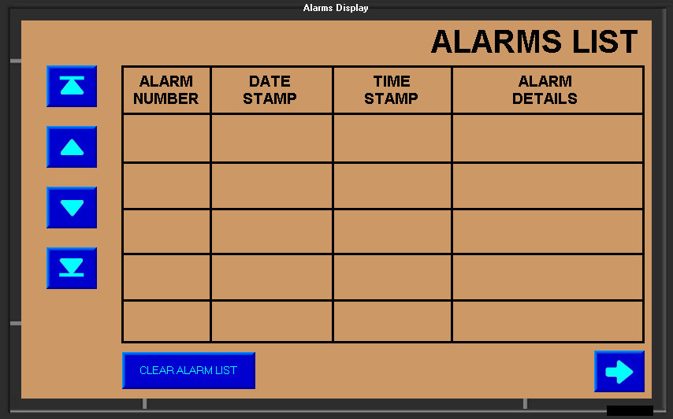

Left buttons

Go To First Record - Sets the top row to alarm record no.1.
(Top button)

Go Up 5 - Moves the top row up five places.
(Second button down)

Go Down 5 - Moves the top row down five places.
(Third button down)

Go To Last Record - Sets the bottom row to alarm record no.50.
(Bottom button)

Others

Clear Alarm List - Clears the whole list. If pressed, a confirmation screen will appear as below.

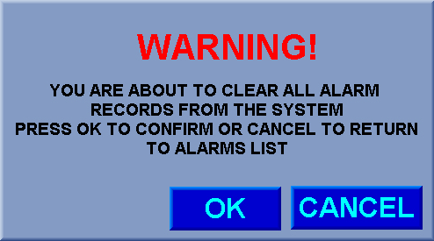

Back Button - (Right arrow) This button navigates back to the main page.

