

ELECTROTEK ANAEROBIC WORKSTATION

AW 400SG SINGLE GAS VERSION

MANUAL

CONTENTS

1. | GENERAL ARRANGEMENT DRAWING OF ANAEROBIC WORKSTATION | 2
2. | GENERAL SPECIFICATION | 3
3. | GAS SUPPLIES | 4
4. | ELECTRICAL SUPPLES | 4
5. | INSTALLATION OF GAS AND ELECTRIC DRAWING | 5
6. | ASSEMBLY INSTRUCTIONS NO. 1. DRAWING | 6
7. | ASSEMBLY INSTRUCTIONS NO. 2. DRAWING | 7
8. | SPECIAL FEATURES | 8
9. | CHECKING THE INCUBATOR ATMOSPHERE FOR OXYGEN | 8
10. | PREPARING THE ANAEROBIC INDICATOR SOLUTION | 9
11. | COMMISSIONING THE CABINET | 10
12. | CHECKING THE GAS FLOW | 11
13. | TRANSFERRING ITEMS INTO THE INCUBATOR | 12
14. | TRANSFERRING ITEMS OUT OF THE INCUBATOR | 12
15. | SINGLE PLATE ENTRY | 12
16. | REMOVAL OF CONDENSATION FROM INSIDE THE INCUBATOR | 13
17. | THE GAS TRAP BUBBLE BOTTLE | 13
18. | THE HEATING AND GAS CIRCULATING SYSTEM | 13
19. | THE TEMPERATURE CONTROLLER | 13
20. | THE GAS CIRCULATION SYSTEM | 14
21. | WORKING INSIDE THE CABINET WITH BARE HANDS | 15
22. | GENERAL MAINTENANCE | 16
23. | CHANGING THE CATALYST AND CONDITIONER | 17
24. | CHANGING THE FLUORESCENT LIGHTING TUBE | 17
25. | CLEANING | 17
26. | TEST REPORT | 18
27. | DECLARATION OF CONFORMITY | 19
28. | CIRCUIT DIAGRAMS

GENERAL ARRANGEMENT OF ELECTROTEK AW400SG ANAEROBIC CABINET

Condensation Plate
Cooling air inlet
Anaerobic indicator bottle
50 ½” (1283mm)
32” (813mm) 15” (381mm)
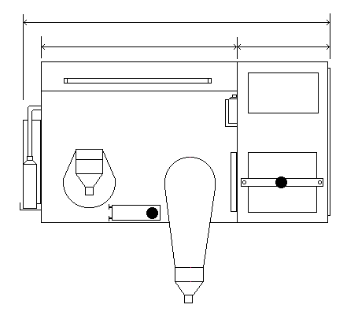
Bubble bottle
Bare hand operation gauntlets
Flushing interlock
60 Petri dish capacity
Manually sealed
interlock doors
Control panel
Single plate entry
Clear acrylic window

27 ½” (698mm)
26 ¼” (667mm)
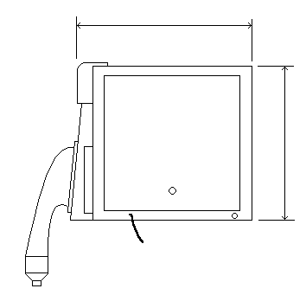
Electrical mains inlet
240v AC 50Hz
Gas inlet
6mm dia. “push – in” connector
Gas outlet

SINGLE MIXED GAS OPERATION - 10% H₂ + 10% CO₂ + 80% N₂
DO NOT EXCEED 10% H₂
GENERAL SPECIFICATION

MODEL AW400SG

LOCK CAPACITY 60 Petri Dishes

MAIN CHAMBER INCUBATION CAPACITY 400 Petri Dishes

DOOR SEALING Manual

GAS Mixed Gas (10% H2 + 10% CO2 + 80% N2)

OXYGEN REMOVAL FROM AIRLOCK Positive Pressure flushing with catalyst

FABRICATION MATERIAL Acrylic

OVERALL DIMENSIONS Length 50 1/2" 1283mm

Depth 27 1/2" 698mm

Height 26 1/4" 667mm

ELECTRICAL SUPPLY 240 VAC 50Hz

GAS SUPPLIES

This Anaerobic Cabinet requires one gas cylinders fitted with a two stage regulator. The output side of the regulator should have a range of 0 - 50 p.s.i. (3.3 bar).

The gas cylinder should contain:

10% Hydrogen + 10% Carbon Dioxide + 80% Nitrogen

CAUTION: GAS CONTAINING MORE THAN 10% HYDROGEN SHOULD NOT BE USED
UNDER ANY CIRCUMSTANCES

The gas pressure at the inlet to the cabinet should be approximately 30 psi (2.0 bar) and the gas flow is as follows:

MIXED GAS 20L/min

The diameter of the pipes connecting the cylinder to the cabinet should be selected according to the length of run to give a minimum pressure drop, this will give maximum gas utilisation.

The cabinet is fitted with a 6mm diameter "push in connector" for the gas.

ELECTRICAL SUPPLIES

VOLTAGE: 240 V.A.C.

CURRENT: 5 AMPS

FREQUENCY: 50 Hz

CAUTION

Switching the Anaerobic workstation “OFF” before it has reached its working temperature can cause the “THERMAL FUSE” protecting the heater to rupture.

We recommend that the heaters are switched off at the control panel if any work is being carried out on the unit requiring switching “OFF” and “ON” or during any commissioning tests.

INSTALLING THE GAS AND ELECTRICAL SUPPLY TO THE AW400SG WORKSTATION

2 stage pressure regulator

Secondary gauge showing pipeline pressure set between 1.6 and 2.5 Bar sufficient to switch low gas pressure indicator “OFF”
Primary gauge showing pressure in bottle
Low gas pressure indicator

Regulator

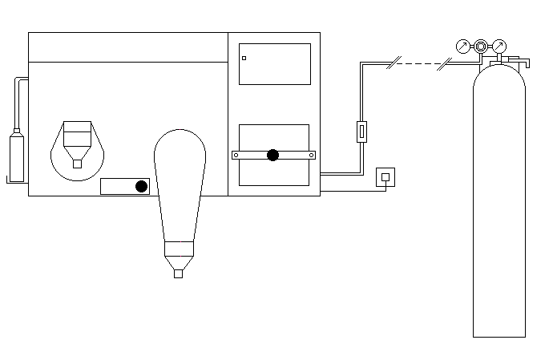
Gas isolation tap close to cabinet
6mm diameter flexible plastic tube 1m long
Electrical supply 240V AC 50Hz
Mount cabinet on strong bench at convenient height
Select tube diameter to give minimum pressure drop when 20 L of gas per minute is flowing. Diameter depends on length of run
Select tube diameter to give maximum pressure drop when 20L of gas per minute is flowing. Diameter depends on length of run
Large gas cylinder containing 9 cubic meters of mixed gas.
10% H₂ + 10% CO₂ +80% N₂

CAUTION:- GAS CONTAINING MORE THAN 10% HYDROGEN MUST NOT BE USED UNDER ANY CIRCUMSTANCES

AW400SG ASSEMBLY INSTRUCTIONS NO. 1 DRAWING

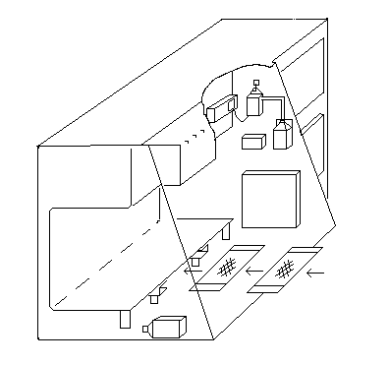
Hang indicator pump here and plug into adjacent socket
Clip anaerobic indicator bottle here
Conditioner
Catalyst
Place conditioning sachet and palladium catalyst sachet in channel under shelf in order shown
Place condensation collection bottle here inside incubator and fit collection pipe from cool plate

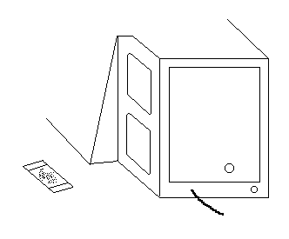
Fit small sachet of catalyst inside roof of lock
AW400SG ASSEMBLY INSTRUCTIONS NO. 2 DRAWING

Insert “Mains Failure” battery and battery holder here
Seal gauntlets with “bungs” when not in use

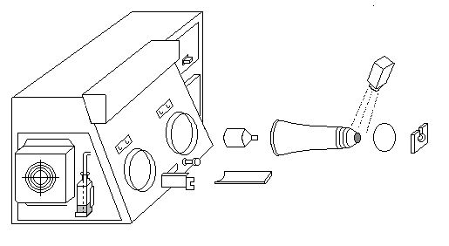
Dust both “Wrist Cuffs” with powder before inserting arms into gauntlets
Gauntlet holder
Arm Ports
Gauntlet hooks
Bung
Gauntlet assembly
Powder
Hang gauntlet on “Gauntlet Hooks” with “Gauntlet Holders” when not in use
Fix gauntlet assembly to “Arm Ports” with “O” rings – ensure there are no creases in the gauntlets underneath the “O” rings to prevent gas leaks
“Push Rod” used to insert dishes into incubator
“O” ring
Fit “Bubble Bottle” here and fill up to line with water

THE ELECTROTEK AW400SG ANAEROBIC WORKSTATION SPECIAL FEATURES

Many special features have been designed into the Electrotek Anaerobic Workstation that cannot be found on any other cabinet. All these have been built in for safety, economy of operation and to make it easier and more comfortable for the operator to use.

MINIMUM BENCH AREA

Although the cabinet will incubate 400 dishes there is still ample room within the unit for the operator to manipulate the cultures.

OPERATOR COMFORT

Quite often the operator has to spend long periods of time working with their arms inside the unit and for this reason the cabinet has been designed so that the operator can work sitting down thereby minimising fatigue. The openings of the glove ports are large, facilitating easy movement of the arms. The viewing area is large, unobstructed by bends in the material which cause the operator to be constantly moving their position. The doors are easily sealed by first closing, then turning the tightening knob. If the unit fails to function because one of the doors has been left open or perhaps a gas bottle has run out of gas then this is indicated clearly on the Control Panel. The unique bare hand working facility allows the operator to get their hands in and out of the cabinet without any fuss. In fact the cabinet has been designed to be very user friendly.

SINGLE PLATE ENTRY LOCK

This lock is used when only a small number of dishes need placing in the incubator. It saves both time and gas. The front door is opened by unscrewing the hinge pin and the dish is placed in the cabinet by pushing it with the bar provided. The dish lid travels up a ramp allowing the escaping gas from the cabinet to flush the air out of the dish before the lid is replaced by the back door. Once the dish is in the incubator the outer door is re-closed by tightening the screw.

CHECKING THE INCUBATOR ATMOSPHERE FOR OXYGEN

The Anaerobic Indicator Solution will indicate traces of Oxygen in the incubator atmosphere by changing colour from being clear when the atmosphere is anaerobic to being blue when oxygen is present. The Indicator Solution is held in a small bottle located at the front of the incubator in the top right hand corner and held in position by a plastic spring clip. The atmosphere from the cabinet is bubbled through the solution by a small aquatic pump. The pump is plugged permanently into an electrical socket and the switch should be left in the "ON" position. The atmosphere of the incubator can be checked for oxygen content by simply switching the socket "ON" on the Control Panel. It is usually sufficient to check the atmosphere perhaps once a day allowing the pump to run
for about 1 minute.

PREPARING THE ANEROBIC INDICATOR SOLUTION

Make up the Anaerobic Indicator Solution from the two ingredients provided, sufficient to fill the bottle about 1/2 full using nine parts of solution "A" and one part of solution "B"

Now place a cap lightly on the neck of the bottle and place it in a bath of water and bring it to the boil. The solution will change from being blue to colourless. Tighten up the cap and remove the bottle from the water allow it to cool and pass it into the cabinet. The cap can now be removed and the outlet pipe from the pump connected to the bottle. The bottle can now be placed in position inside the bottle holder where it will be in full view.

We recommend replacing the solution on a weekly basis.

COMMISSIONING THE CABINET

Check all the following points before starting to commission the workstation.

1. Switch "OFF" the cabinet at the Mains ELCB switch

2. Open the Mixed Gas Regulator, set the secondary gauge to give a maximum pressure of 25 psi (1.67 Bar) at the inlet to the unit with the gas flowing

3. Ensure that the Gas Trap Bubble Bottle is filled up to the water level line and the gauntlets and bungs are both fitted to the cabinet. (Page 7)

4. Hang the Indicator Pump on the hook adjacent to the electrical socket, plug the pump into the socket and switch "ON". Place the Anaerobic Indicator Bottle in position, filled to the appropriate level with Indicator Solution and connected to the pump with the flexible tubing. (See Instructions regarding preparation of the solution on (Page 9)

5. Check that the Atmospheric Conditioning Sachet and the Palladium Conditioning Sachet are in position underneath the shelf. The Atmospheric Conditioning Sachet should be put in first to the rear of the cabinet. Place the small Palladium Catalyst in the roof of the Lock
(See Sketch on Page 17)

6. Now switch on the cabinet at the ELCB. If the "Low Gas Pressure" neon is illuminated, increase the gas pressure until the neon goes out.

7. Switch the light "ON"

8. Check that the heater fan is working and that the heater light is illuminated.
(see WARNING NOTE regarding Thermal Fuse).

9. Switch the Socket "ON" and the Anaerobic Indicator Solution should turn blue.

10. Switch the Dehumidifier "ON" and set the humidistat to 70% RH. (Relative Humidity)

11. After closing all the doors, remove the clip from the Commissioning Switch and switch "ON". Press the "Lock Flush" button and gas will start to flow in pulses into the Cabinet.

12. Although the gas flow has been set to 20 litres per minute at the Factory, check that this setting is correct by inserting a Gas Flow Meter and a Pressure Gauge into the inlet pipe line.
(See Page 11)

13. Leave the Commissioning Switch in this position for one hour or until the Anaerobic Indicator turns colourless.

14. At this stage the cabinet is anaerobic. Switch the Commissioning Switch "OFF" and replace the clip to prevent switching it on accidentally.

15. The temperature of the unit will take several hours to settle down.

16. Now check all the functions are working.

CHECKING THE GAS FLOW

To check the Gas Flow into the Workstation the following equipment is required:

- Gas Flow Meter (0 – 30 Litres per minute)
- Pressure Gauge (0 – 3.3 Bar)

Connect up the equipment as shown and start the “Lock Flush”

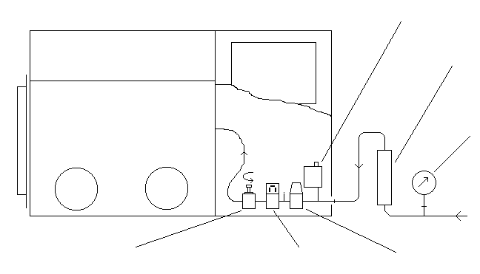
Inlet Pressure Switch
Flow Meter
Pressure Gauge
Pressure Regulator –
Outlet Pressure set at 1 Bar
Inlet Solenoid
Flow Regulator

$\text{ Gas Flow = Flow Meter Reading }\sqrt{\frac{\text{1 + Pressure Gauge Reading}}{1}}$

e.g.: Gas flow required = 20 L / minute

Pressure Gauge Reading shows 2 Bar

$\text{Flow Meter Reading= }\frac{\text{20}}{\sqrt{\frac{1+2}{1}}}=\frac{\text{20}}{1\text{.}\text{73}}=\text{11}\text{.}\text{56}L\text{/min}$

Any adjustment to the gas flow should be made using the “Flow Regulator” situated at the end of the gas train.

TRANSFERRING ARTICLES IN AND OUT OF THE CABINET

TRANSFERRING ITEMS INTO THE INCUBATOR

The Workstation is supplied with ten stainless steel Petri Dish Holders, each capable of holding ten Petri Dishes. These are used for transferring dishes into and out of the cabinet and stacking them whilst they are being incubated.

To get dishes into the incubator simply load up the Holders and open the 0uter Door by turning the knob and placing the holder inside the lock. When the door is re-closed, the atmosphere inside the lock is made Anaerobic by pressing the "Start Lock Flush" button.

The atmosphere within the lock is automatically replaced several times until the oxygen content is sufficiently low to allow the Inner Door to be opened. At the end of the flushing operation which takes five minutes, the "Lock Anaerobic" Indicator on the Control Panel will become illuminated.

At this point place the hands inside the incubator using the glove ports (see Working inside the cabinet with bare hands Page 15). Open the Inner Door and transfer the contents of the "Lock" into the incubator section of the unit.

TRANSFERRING ITEMS OUT OF THE INCUBATOR

To unload the contents of the incubator check that the Neon Indicator inside the cabinet is not illuminated then open the Inner Door, place the items into the Lock and re-close the Door. Withdraw the arms from the glove ports and seal them. The items can now be removed from the cabinet by Opening the 0uter Door.

SINGLE PLATE ENTRY

Single dishes can be placed into the incubator by opening the small door situated between the two glove ports and pushing them into the cabinet with the bar provided. The positive pressure within the cabinet ensures that no oxygen enters the unit during this operation.

CAUTION: TAKE CARE NOT TO DAMAGE THE DOOR SEAL WITH ANY SHARP OBJECTS WHILST CARRYING OUT THE ABOVE OPERATIONS.

THE REMOVAL OF CONDENSATION FROM INSIDE THE INCUBATOR

Water vapour accumulates inside the incubator atmosphere from two sources, firstly from the evaporation of the media in the Petri dishes and secondly by the hydrogen and the traces of oxygen being linked together by the palladium catalyst. If this water vapour is not removed it will condense on the cooler surfaces of the incubator walls and form pools of water. The cabinet however is fitted with a large aluminium Condensation Plate which is kept a few degrees lower than the temperature inside the incubator by a fan which blows cool air from the room onto its outer surfaces. This reduction in temperature is sufficient to cause the excess water vapour inside the incubator to condense, run down its surface and collect at the bottom and finally fall via a drain tube into the collection bottle situated inside the cabinet. When this is full, remove it via the lock.

The fan for the Condensation Plate can be switched "OFF" at the Control Panel if the Service Engineer is working on the unit. The humidity within the incubator is controlled by the Humidistat which is mounted just above the inner door. The Humidistat switches the fan "ON" and "OFF" automatically.

THE GAS TRAP BUBBLE BOTTLE

The Gas Trap Bubble Bottle is mounted on the incubator endplate just beneath the Condensation Plate and has several functions. Firstly, it is a safety device so that in the event of the Input Solenoid remaining open, the gas has a way of getting out of the cabinet and not doing any damage to the structure of the unit. Secondly, it allows the operator to be able to push their arms inside the cabinet without applying undue pressure. It must be remembered that all gas that gets out of the cabinet via the bubble bottle is wasted and therefore every effort must be made to minimise this when working inside the incubator. If one arm is withdrawn as the other arm is pushed into the unit, gas wastage can be reduced.

THE HEATING AND GAS CIRCULATING SYSTEM

The heating and gas circulating system consists of one tubular 400 Watt heater fixed directly behind the fan unit mounted on detachable plates in the top of the incubator. The fan runs continuously whilst the heater is burst fired.

THE TEMPERATURE CONTROLLER

An adjustable electronic temperature controller fitted in the control panel of the cabinet regulates the temperature. The controller has a temperature sensor in the right hand top corner of the heating chamber and the temperature of the incubator can be adjusted between 3 degrees C above ambient to 40 degrees C. There is a green led incorporated in the temperature controller which indicates when the heater is operating and a temperature display to give an accurate reading of the internal temperature of the cabinet. A data sheet covering the temperature controller is included with this documentation.
.

THE GAS CIRCULATION SYSTEM

The fan units pick up the cooler incubator atmosphere which has been forced to the top of the incubator and first passes it over the warm heater. This warmer gas is now forced down the channel at the back of the cabinet then it passes under the bottom shelf of the incubator where it first meets the sachets of Conditioner and then the sachets of Catalyst. The gas now gives up just sufficient of its heat to maintain the required temperature before finding its way back to the top of the incubator due to the suctional force of the fan.

WORKING INSIDE THE CABINET WITH BARE HANDS

Although the Electrotek cabinet can be used with long sleeved gloves it is much easier to work with bare hands. This bare hand facility is achieved in a very simple but effective way. The Bare Hand Gauntlet Assembly consists of four components as shown in diagram 1.

1. Sleeve 2. Solid Ring 3. Cuff 4. Bung

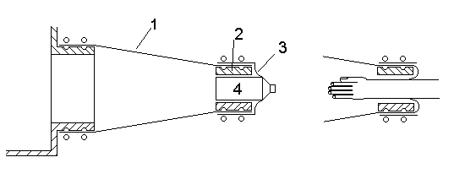

Diagram 1

Diagram 2

The inside of the sleeve is always held at positive pressure by the Gas Pressure Switch, therefore if the Bung is removed from the Cuff, gas will flow out of the cabinet and no oxygen will enter.

To insert the hand into the cabinet simply lift up the end of the gauntlet and push the Bung into the cabinet using the tips of the fingers only, followed by the hand ( Note:- Do not grip the end of the bung with the fingers). The Cuff will seal around the wrist as shown in diagram 2. Now place the Bung inside the cabinet in a convenient position.

To remove the hands from inside the cabinet, simply collect the Bung and release it within the sleeve. Remove the hand and let the Bung fall into the Cuff where it will seal. Gravity will now hold the Bung in place. Do not attempt to pull the bung back into the cuff.

ALWAYS ALLOW THE SLEEVE TO FILL WITH GAS BEFORE INSERTING OR WITHDRAWING THE HAND.

If the hands and Cuffs are lightly dusted with talcum powder the operation becomes very simple.

If the Cuffs are too tight around the wrists they can be trimmed to a more comfortable fit with a sharp pair of scissors. However they must be sufficiently tight to prevent gas escaping whilst working inside the cabinet.

Two hooks are provided just above the arm ports together with a Gauntlet Holder for use when the Gauntlets are not being used. If the Gauntlet is fitted into the Gauntlet Holder about half way up its length, the Holder can be clipped onto the hook. This has two effects: firstly it prevents the Gauntlets hanging down and getting in the way and, secondly, it greatly reduces condensation in the Gauntlet Assemblies.

GENERAL MAINTENANCE

The Electrotek Workstation, unlike other units, uses the energy contained in the gas bottles to do most of the work required. This means that there are no evacuation or circulation pumps to maintain.

Many of the components used in the construction of the unit are available "off-the-shelf" in almost every part of the world. However, all spare parts are readily available from Electrotek.

We recommend that the items below are replaced as indicated. However experience shows that they last approximately twice this period.

RECOMMENDED LIST OF SPARES AND REPLACEMENT PARTS FOR AW400SG

Quantity Description Recommended Replacement

2 Gauntlets 1 year
2 Cuffs 6 months
2 Fans 2 years
1 Heater 3 years
1 Outer Door Seal 6 months
1 Inner Door Seal 6 months
1 Single Port Door Seal 6 months
2 Large "O" Rings 6 months
6 Small "O" Rings 6 months
1 Spotlight Bulb 2 years
1 Catalyst Sachet Large 2 year
1 Catalyst Sachet Small 2 year
1 Sachet Conditioner 1 year
1 Alarm Battery 1 year

SCHEDULE OF RECOMMENDED PREVENTATIVE MAINTENANCE TASKS FOR AW400SG

Task Interval

Check operating temperature 6 months
Check thermometer 6 months
Check solenoid seals 2 years
Check gas flow and recalibrate 6 months
Check for gas leaks 6 months
Change alarm battery 6 months
Check ALL functions are operating 6 months

WE RECOMMEND THAT ALL THE ABOVE MAINTENANCE WORK IS CARRIED OUT BY
A TRAINED SERVICE ENGINEER

CHANGING THE CATALYST AND CONDITIONER

The sachet of Catalyst and the sachet of Conditioner which are housed beneath the bottom shelf of the incubator will require replacing at a period in excess of one year. If for any reason the sachet of catalyst gets wet, the contents can be dried out by heating to a temperature of 160°C for a period of two hours. The sachet of conditioner can, if necessary, be dried at room temperature. The chemicals can then be returned to their respective containers for further use. Each sachet contains 0.5Kg of material.

When replacing the sachets, ensure that the sachet of Atmospheric Conditioner is at the REAR of the cabinet so that the gas passes over it first. (See sketch below)

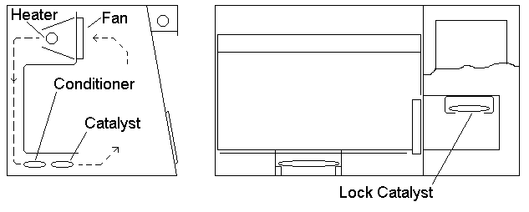

There is also a sachet of catalyst housed in the roof of the lock. This sachet can be both inserted and removed by bending it slightly and sliding it in or out of the holder.

CHANGING THE FLUORESCENT LIGHTING TUBE

Switch off the power to the light on the Control Panel and remove the three screws from the top and the two plastic screws from the front of the Light Shade. The tube can now be removed from its Holding Clips, the end caps disconnected and the new tube fitted.

CLEANING

The inside of the cabinet can be swabbed out with a weak solution of general laboratory detergent and warm water, and dried with a soft cloth. In the event of a culture spillage, a 5% Hypochlorite solution should be applied to the area and left for half an hour. It should then be wiped and swabbed with a 1% solution of Sodium Thiosulphate. Remove the catalyst and conditioner from the unit while the Hypochlorite solution is being used.

TEST RECORD SHEET

MODEL AW400SG
SERIAL NO 2006
CUSTOMER
FLUSH CYCLE 4 SECONDS ON 2 SECONDS OFF
FLUSH DURATION 5 MINUTES
MIXED GAS FALLING CUT OUT PRESSURE
MIXED GAS RISING SWITCH ON PRESSURE
MIXED GAS FLOW L / MIN
L / LOCK FLUSH
MIXED GAS INPUT PIPE SIZE 6 mm DIA
INCUBATOR POSITIVE PRESSURE SETTING 6 mm WG
INCUBATOR LEAK NOT DETECTED 1 HOUR
TEMPERATURE SETTING 36.5 deg C
OVER TEMP SETTING OF THERMAL FUSE 72 deg C
LIGHT INTERNAL SOCKET
SPOTLIGHT COMMISSIONING SWITCH
HUMIDISTAT INNER DOOR
MIXED GAS FLOW OUTER DOOR
LOCK FLUSH DIGITAL THERMOMETER
LOCK ANAEROBIC GAS FLOW ELCB
ALARMS GAS LEAK SETTING 2 MINS.

CHECKED BY DATE



Declaration of Conformity

Equipment Anaerobic Incubator type AW400SG

Manufacturer Electrotek

Address 71 Nab Wood Drive, Shipley, West Yorkshire BD18 4EW

Description of Equipment Incubator for the environmentally controlled incubation of anaerobic bacteria.

I certify that the apparatus identified above conforms to the requirements of Council Directive 89/336/EEC

Signed Date

Position/status Proprietor, Electrotek.

